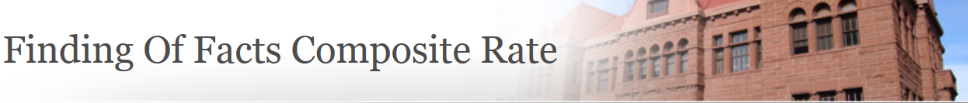
Current Composite Rate for County Counsel
Effective July 15, 2022, the composite rate for County Counsel using the County Wide Cost Allocation Plan costs for fiscal year (FY) 2022-2023 is $204.88 an hour. It should be noted that Allocation Plan rates lag behind the current fiscal year. It is anticipated that this rate will change annually.
FINDINGS OF FACTS FEES
ASSESSMENT APPEALS BOARD AND HEARING OFFICER RULES OF PROCEDURE, RULE 12
Example:
- Single-family residences under $500,000 in assessed value, will be charged a flat fee equal to two hours. Using the FY 2022-2023 composite rate of $204.88 an hour, the flat fee is $409.76.
- Residences valued above $500,000, or business property, personal property, commercial, industrial, and rental properties (secured and unsecured property), an initial deposit equal to five hours of County Counsel time at the FY 2022-2023 composite rate of $204.88 an hour, requires a deposit of $1024.40 prior to the commencement of the hearing. The time expended by the assigned Deputy County Counsel will be billed accordingly and any balance due will be paid before the requested Findings are released. Any unused portion of the deposit will be returned.
If you have any questions, please feel free to contact the Clerk of the Board at (714) 834-2331, ext.1.

